Pupil voice 2025
Maths

Headlines
Children enjoy maths and like learning new skills.
Children solve problems and reason in their maths lessons (explain answers)
Children know that maths is important and they use it in other subjects like science and geography.
Children know when they have achieved their learning, what helps them to improve and what their teacher does to challenge them further.
Children learn their times tables and know that there is a big focus on this fluency.

Actions
Encourage further maths learning at home/KIRFs/Fluency homework
Ensure GD pupils are challenged
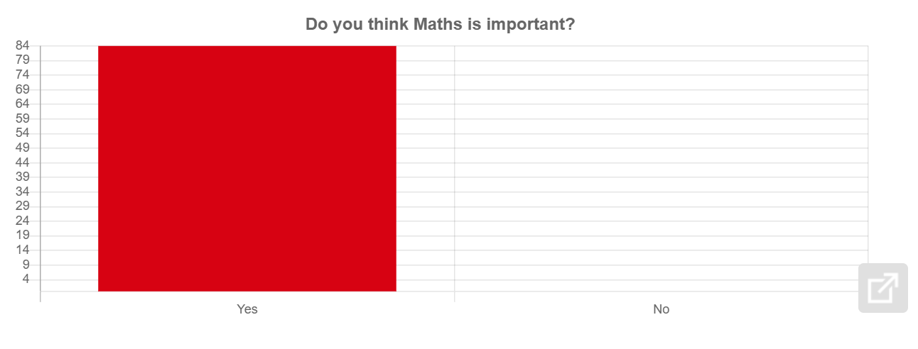
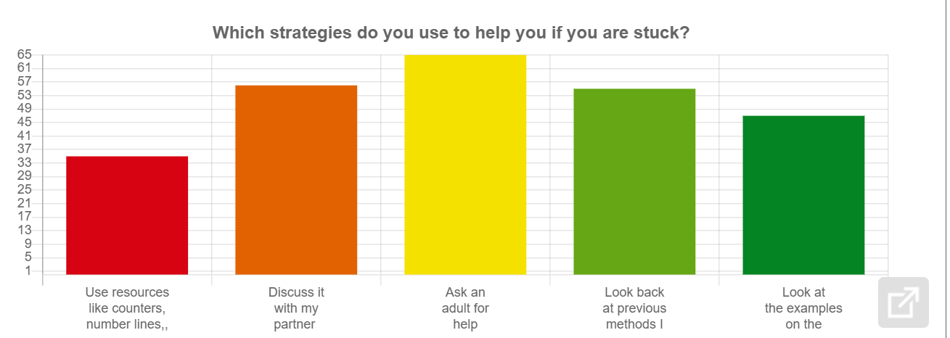
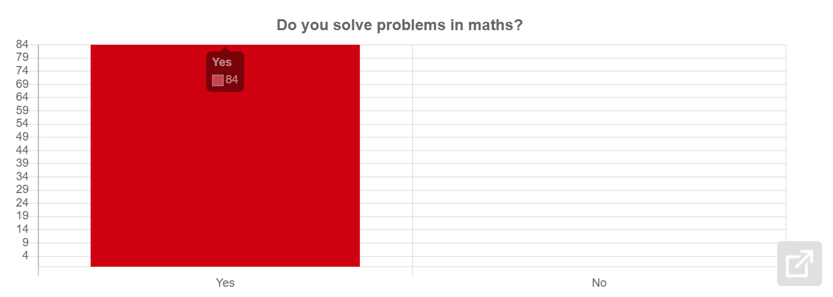
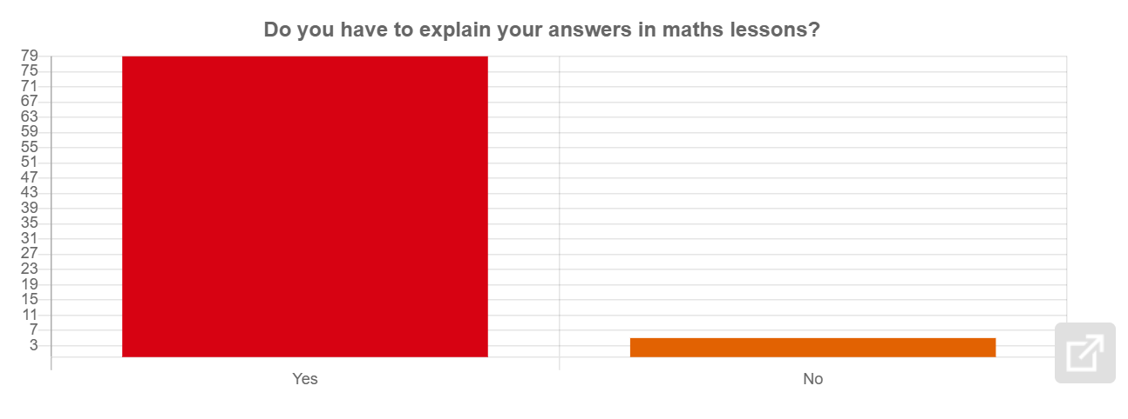
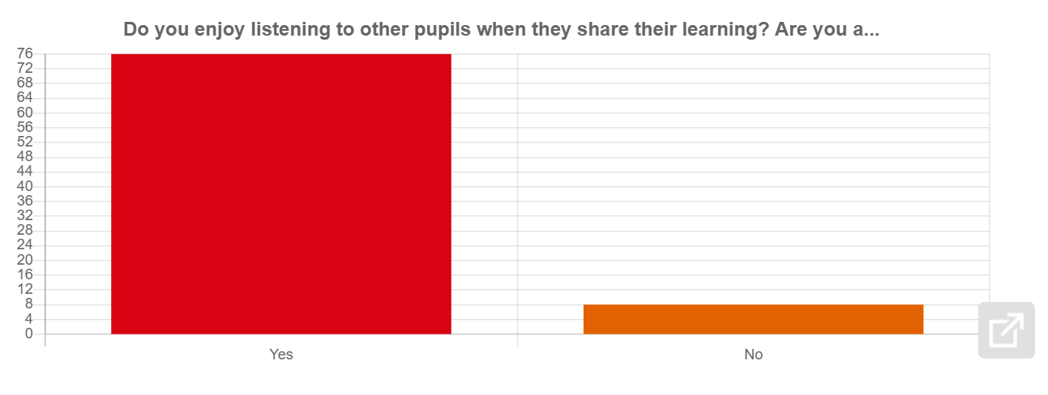
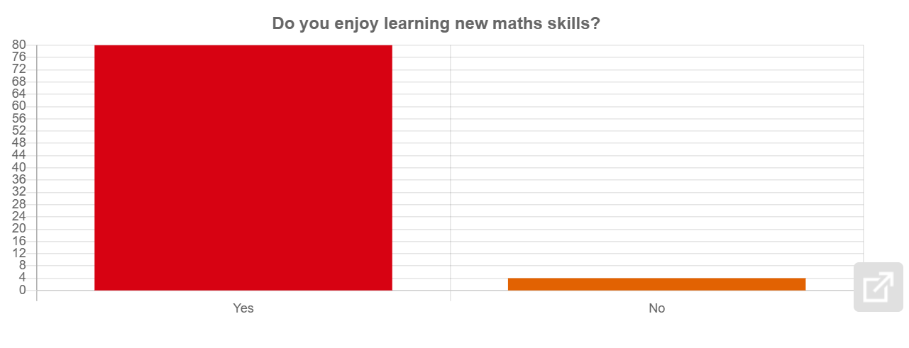
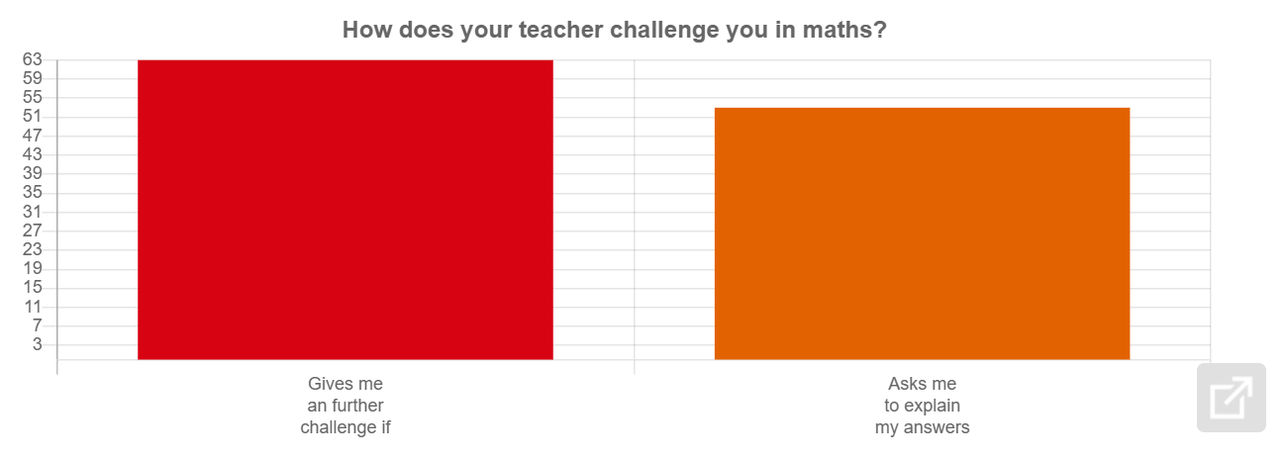
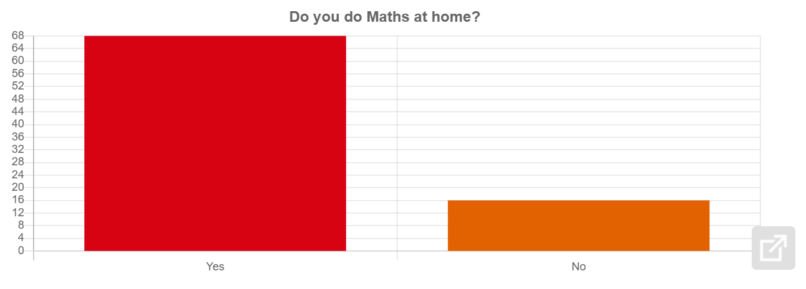
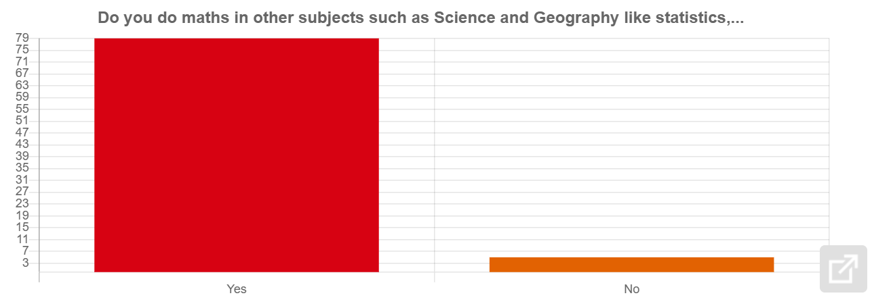
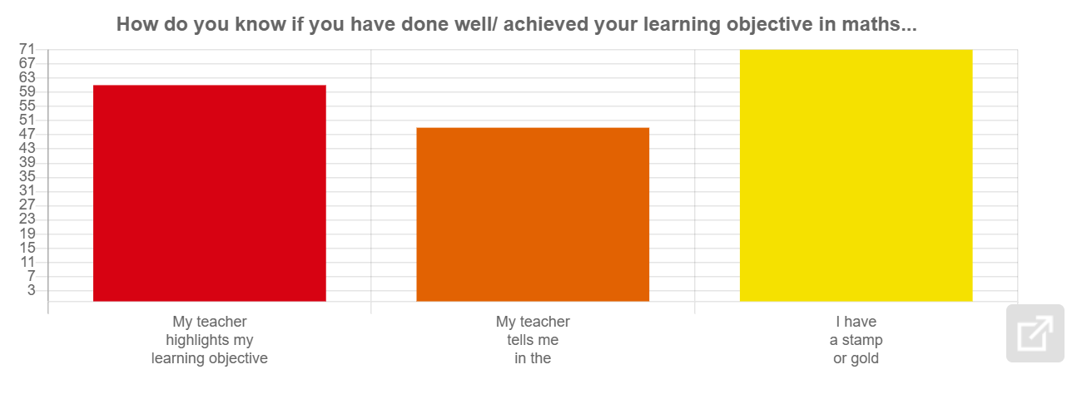
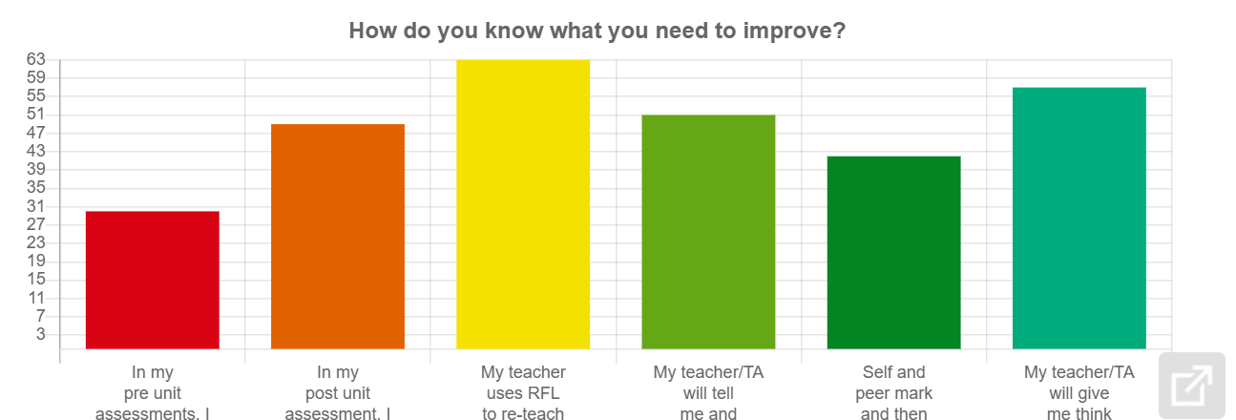
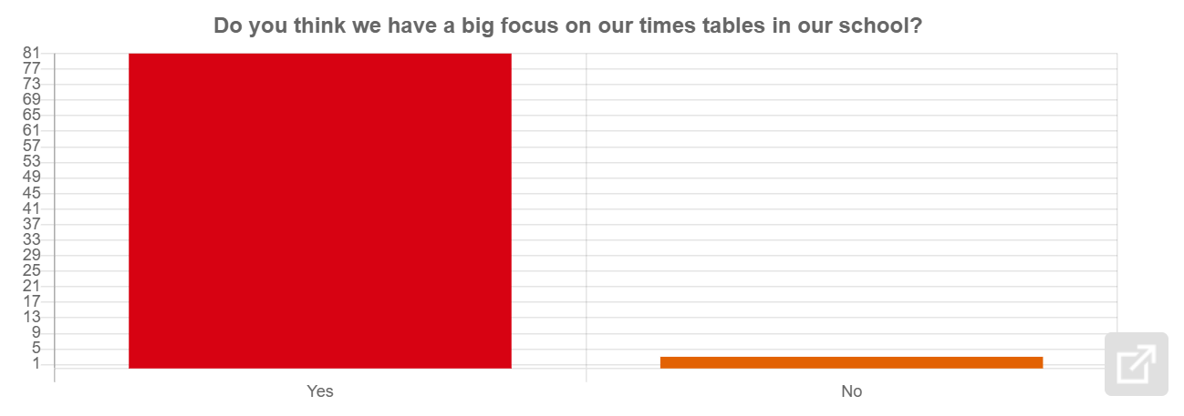
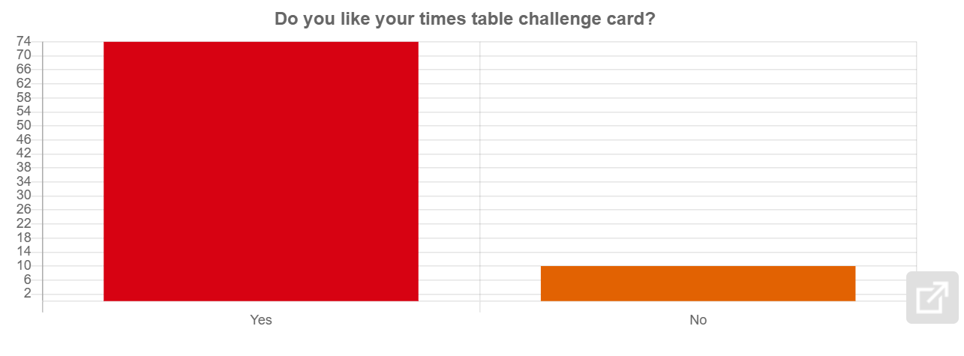
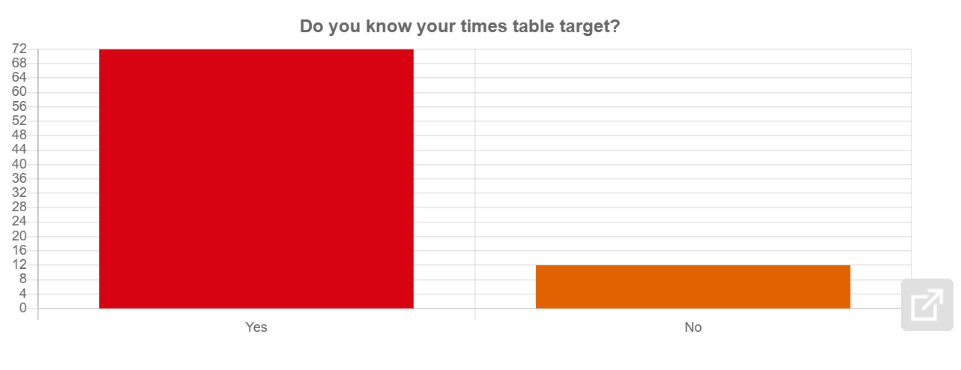
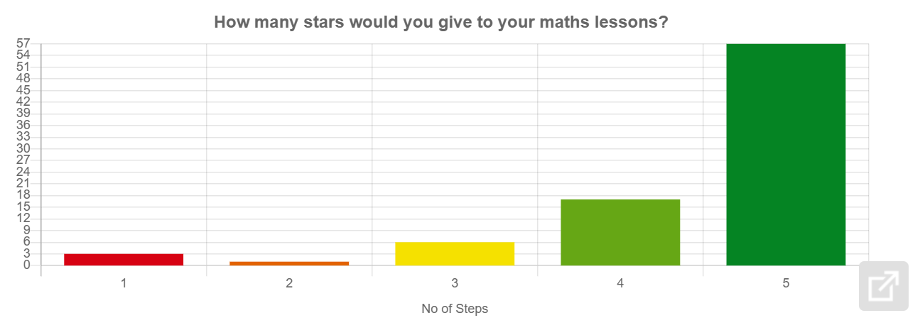
1 : we could improve by changing the time table because our class is slow on our maths so we have more time. and doing maths outside for a treat . so mrs davies can take out children who are doing there work good.
2 : doing your maths outside.
3 : work it out quicker and think more and be more reasonable
4 : More maths eqipement
5 : We could use maths method ,maths equipment.
6 : More practical questions and in more groups of people and doing maths in the fresh air outside.
7 : more resources to help workout and more challenges . doing maths outside on benches once a week
8 : challenge us
9 : I don't know
10 : By making it more fun!!!!!
11 : Maybe have some easy hard and real hard
12 : I want to do more drawing
13 : I think maths doesnt really need any improving the teachers are very good at teaching us it
14 : you dont need to improve
15 : At the end of the lesson to do more maths games
16 : i do not know
17 : No way you could improve the maths its great and educational for our school and other people
18 : we could learn it at home
19 : by geting better at maths
20 : NOTHING everything does not need to be improved!!!!!!!
21 : make it less boiring and more FUN
22 : numberline
23 : Learn more about maths
24 : am Happy in math
25 : we could put harder problm
26 : by learning and making better improvement and concretion.
27 : maybe let us start earlier because we don`t get to get all of it done
28 : "To me, I don't know what else we need to improve in maths in our school , but , I would say that we need to take it slow on those who are struggling or need more help." - Adrian Nwosu
29 : we would like to do more rfl
30 : More harder questions. A little help.
31 : More hard questions
32 : Mabey do more harder questions and not to hard thank you for being a great teacher
33 : better explanations.
34 : have more time on a unit more than a half term.
35 : More step 3
36 : To do harder questions
37 : Do more step3 questions
38 : Edie thinks nothing and Qusai think more work.
39 :
40 : Listening to your partner more
41 : Not a thing
42 : Get more resources and more challenges.
43 : To have different groups of people
44 : they could let us sit out side on a friday
45 : No answer. - Noah B
46 : "I think we can improve maths in our school by taking it easy on those who are struggling or those who need more help." - Cillian
47 : use a nummberline
48 : leaning more things
49 : I think we could do a Bit more harder questions.
50 : Have more equipment like counters and more challenges
51 : I can improve my working out.
52 : i'm not sure maths is good
53 : if it was a little easier
54 : EVERYTHING
55 : I am happy in maths
56 : less challenges
57 : Can keep it easy with the kids that need help
58 : By lisening by practise at home
59 : like show working and be confident.
60 : we calldent
61 : I Like my maths lesson
62 : Learning new stuff like division subtracting adding multiplication and fractions
63 : make it harder
64 : By doing more step3
65 : can do had worck
66 : oscar.more times tables like 50 times. temwani:by doing more work and doing more challenges.
67 : We could get more resources and provide more step 3 questions. We could have longer and harder units which will be useful
68 : Do more harder questions.Get more recources and do step 3
69 : by helping others by using more math utilities
70 : more maths
71 : More practice and more challenges
72 : I think that the school cannot improve maths
73 : Make it more fun.
74 : Learn more maths
75 : we could add much harder problems
76 : we could have robots that do our work for us !
77 : not sure
78 : I would improve my subtraction
79 : like more maths equipment
80 : get beter every dAY
81 : We could do a maths test every day or else level down.
82 : listen to your partner
83 : More step 3 questions.
84 :

