





Maths Policy

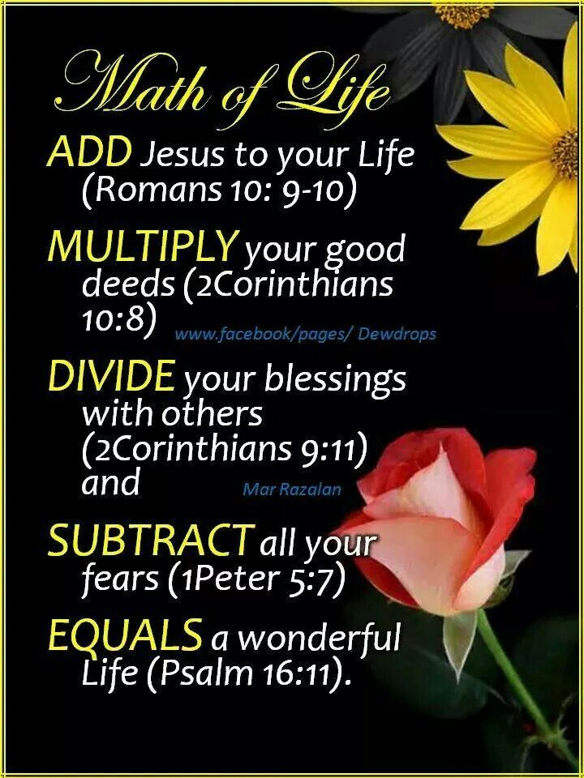

Policy Type | Policy Number | Prepared By (Job Title) and Date
 |  | Head of School and Curriculum Leader
Approval Date | Review Frequency | Review Due Date
Signed on behalf of the Full Governing Body:

_____________________________

What is our Maths Culture?

Creating fluent problem solvers
At Shrewsbury Cathedral Catholic School we aim to inspire all children to reach their full academic potential. In mathematics, this means ensuring a curriculum that is meaningful, contextual and fully inclusive.
At SCCPS we believe that every child can master an understanding and love of maths. We aim to ensure that all our pupils develop into enthusiastic mathematical thinkers who are ready to take on the world of mathematics by the time they leave us in year 6. Maths is delivered through an ambitious, connected and sequenced curriculum accessible to all pupils in our school from Reception to year 6. Using the an adapted White Rose Maths Scheme, KIRFs and Mastering Number, we not only cover all the content of the National curriculum but ensure it is sequenced in a way which maximises all pupils’ understanding of maths and supports its pedagogy. Through our well-thought-out scheme of work, we plan for our pupils to be confident mathematicians who have achieved fluency in all aspects of the curriculum. We have the highest expectations of every learner; we want our pupils to master maths rather than having only surface knowledge and skills in this subject.
We aim to develop lively, enquiring minds encouraging pupils to become resilient , collaborative and mathematically fluent enabling them to be problem solvers which will become an integral part of their future. At Shrewsbury Cathedral Catholic School we aim to inspire all children to reach their full academic potential. In mathematics this means ensuring a curriculum that is meaningful, contextual and fully inclusive.

Intent
Our school offers a broad foundation of mathematical experiences designed to provide all pupils with the understanding, skills and knowledge needed to deal with everyday situations and experiences. A sound understanding of Mathematics enables children to understand and appreciate relationships and pattern in both number and space in their everyday lives. We aim for children to master number sense fluently.

Our Curriculum intends that pupils;
- Become fluent in the fundamentals of mathematics, including through varied and frequent practice with increasingly complex problems over time, so that children have conceptual understanding and are able to recall and apply their knowledge rapidly and accurately
- Reason mathematically by following a line of enquiry, conjecturing relationships and generalisations, and developing an argument, justification or proof using mathematical language
- Can solve problems by applying their mathematics to a variety of routine and non-routine problems with increasing sophistication, including breaking down problems into a series of simpler steps and persevering in seeking solutions.

Implementation

At Shrewsbury Cathedral Catholic Primary School we use a variety of teaching and learning styles in mathematics lessons as recommended by the National Curriculum (2014) and Shrewsbury Cathedral Catholic Primary School’s own calculation policy and progression document linked to White Rose and supported with other resources including Isee, NCETM and NRICH. All of our planning and teaching is based on the 5 BIG IDEAS:
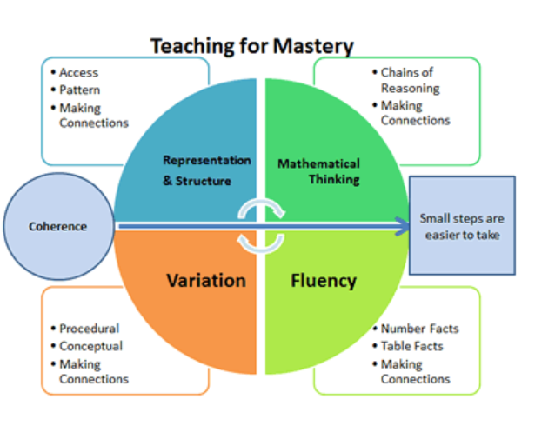

Our principal aim is to develop children’s knowledge, skills and understanding in mathematics. We do this through a daily lesson which combine whole class, individual and group teaching methods. During these lessons we encourage children to ask as well as answer mathematical questions with reasoning and to reflect upon their strategies for solving these questions and problems, as outlined by the National Curriculum.

Displays will reflect the current learning within the classroom through the use of working walls and key vocabulary displayed. Children use IT in mathematics lessons when appropriate. Wherever possible, we encourage the children to use and apply their learning in everyday situations and look for opportunities throughout the whole curriculum to extend and promote mathematics.

In all classes there are children of differing mathematical ability. We recognise this fact and provide suitable learning opportunities for all children through the use of scaffolding to support learning and questioning to deepen learning. Children build their skill set within a lesson through the teaching and learning of declarative, procedural and conditional maths.

EYFS
Four Mastering Number sessions are planned, delivered and assessed a week. Each session lasts 10-15 in KS1 and 45 minutes in Reception and exposes all children to key mathematical concepts so that they can be explored together, as a class. During each session, adults assess which children need further opportunity to consolidate the new learning. These children then work in a small focus group to ensure they are ready for the next session. Enrichment opportunities are planned to enhance the children’s continuous provision and are also built into their daily routines.
The fifth maths session of the week focuses on teaching Shape, Space and Measure. The outlined progression is informed by the research conducted by the NCETM https://www.ncetm.org.uk/in-the-classroom/early-years/. We cover 3 areas of early mathematics learning (Pattern, Shape and Space, Measures) which collectively provide a platform for everything children will encounter as they progress through their maths learning at primary school, and beyond.
Four Mastering Number sessions are planned, delivered and assessed a week. Each session lasts 10-15 in KS1 and 45 minutes in Reception and exposes all children to key mathematical concepts so that they can be explored together, as a class. During each session, adults assess which children need further opportunity to consolidate the new learning. These children then work in a small focus group to ensure they are ready for the next session. Enrichment opportunities are planned to enhance the children’s continuous provision and are also built into their daily routines.
The fifth maths session of the week focuses on teaching Shape, Space and Measure. The outlined progression is informed by the research conducted by the NCETM https://www.ncetm.org.uk/in-the-classroom/early-years/. We cover 3 areas of early mathematics learning (Pattern, Shape and Space, Measures) which collectively provide a platform for everything children will encounter as they progress through their maths learning at primary school, and beyond.
KS! And KS2
During lessons children will practise
- Key Instant Recall Facts (KIRFs). These are designed to support the development of the mental skills that underpin much of the mathematics work in school. They are particularly useful when calculating (adding, subtracting, multiplying or dividing) Please see KIRFs link for further details
- RFL. This is a daily starter activity consisting of one question each from a topic covered last lesson, last week, two or three weeks ago and last term or last year. This is to encourage children to revisit learning and to aid the quick recall of previously taught knowledge and skills.
- Central to our mathematics teaching is the CPA approach (Concrete-Pictorial-Abstract sequence). Manipulatives (or resources) are accessible for all children in every classroom to use as directed or independently. This approach helps pupils understand mathematics and to make connections between different representations.
- Children are encouraged to use the correct mathematical vocabulary and use sentence stems to help shape their answers and explain their reasoning. Working walls are used to support learning and include key vocabulary and useful strategies.
- Within and across lessons children will use; Fluency – pupils understand and can apply the fundamentals of mathematics in a variety of situations; Reasoning – pupils follow a line of enquiry, conjecture ideas, and develop an argument, justification or proof using mathematical language; Problem solving – pupils apply their skills to a variety of problems, breaking them down into smaller steps and persevering to find a solution.
- Instant assessment and feedback are given by adults through 'Helicopter Marking' and teaching is then adapted when needed.
- Teachers use a Ping-pong approach by modelling and doing.
- Learning challenges thinking
.
Teachers and TAs will facilitate all learning through quality first teaching and supporting children in whole class situations, smaller groups and 1:1 teaching where necessary. Teachers identify gaps in children’s learning and provide opportunities for these children to have interventions to support their learning which include pre teaches, precision teaching and specific intervention programmes such as Power of 2.

KS1
In KS1 all lessons begin with a 15 minute ‘Mastering Number’ session to develop and embed fluency in number bonds, number sense and calculations

KS2
To develop recall and retrieval all lessons in KS2 begin with 4 Retrieval For Learning questions. These questions address learning from the day before, the week before, a unit before and an area which needs to be addressed from teacher assessment. In LKS2 daily sessions are given to timestables practise.

Children in all classes are provided with half termly Key Instant Recall Facts which are learnt at home as well as at school. This supports children’s recall and frees up space and energy for them to learn deeper.

Mathematics Curriculum Planning

Mathematics is a core subject in the National Curriculum. At Shrewsbury Cathedral Catholic Primary School and Nursery, we implement the statutory requirements of the programme of study for mathematics using the National Curriculum and our own planning framework. We carry out the curriculum planning in mathematics in three phases (long-term, medium-term and short-term) to ensure coverage of the key objectives for the year and that pupils are making progress over time.

Long Term Planning (LTP)
We follow the White Rose LTP planning. The long- term planning shows deep coverage of the National Curriculum units. Units are taught in sequence which supports progression and building on knowledge. For example place value is taught first, followed by addition and subtraction based on the fact that place value knowledge is needed for addition and subtraction. Multiplication then follows on as again multiplication is repeated addition.

Medium term Planning (MTP)

Our medium-term mathematic plans give details of the main teaching objectives for each unit and define what we teach. All planning ensures an appropriate balance and distribution of learning across the term. Each unit is planned and supported through a unit cover which outlines the intent, the learning objectives and the key vocabulary for the unit. Throughout the whole curriculum we develop mastery, mastery with greater depth and promote mathematicians.

Short Term Planning (STP)

All teachers are expected to have a presentation including Learning Objective, Models, images and questioning as well as practical resources. The presentation must begin with RFL. Learning should provide opportunity for declarative , procedural and conditional teaching and learning. The lesson or lessons should develop through concrete-pictorial-abstract. These presentations must be ASD friendly.
Examples of slides
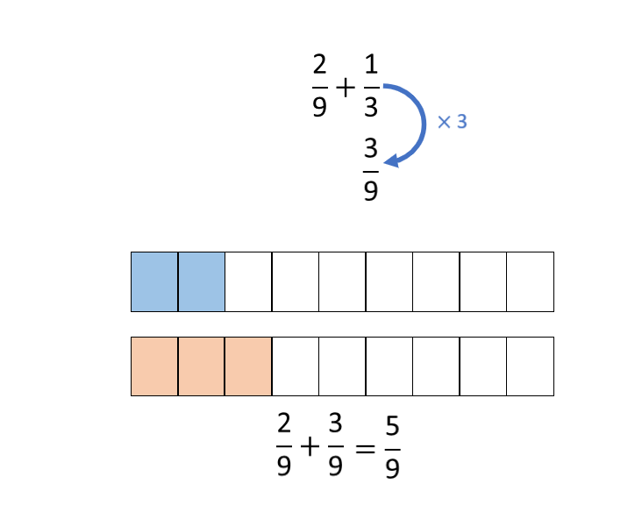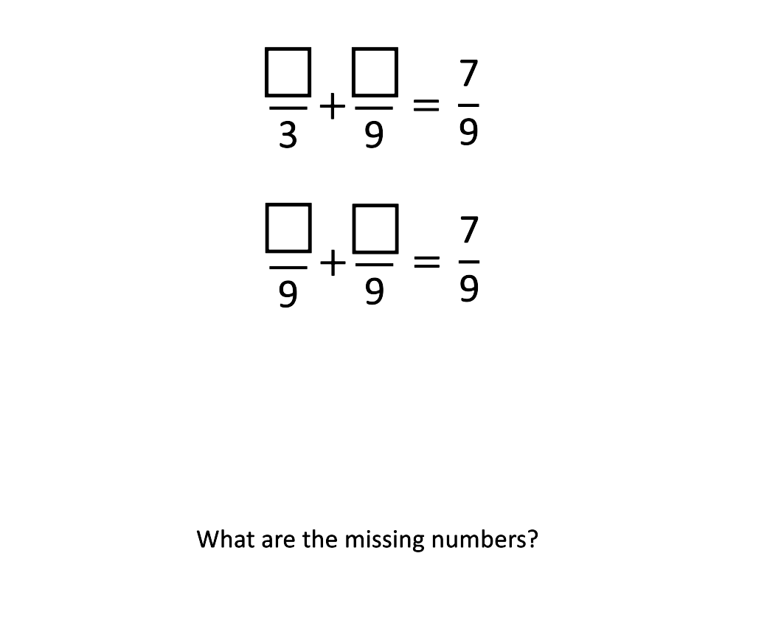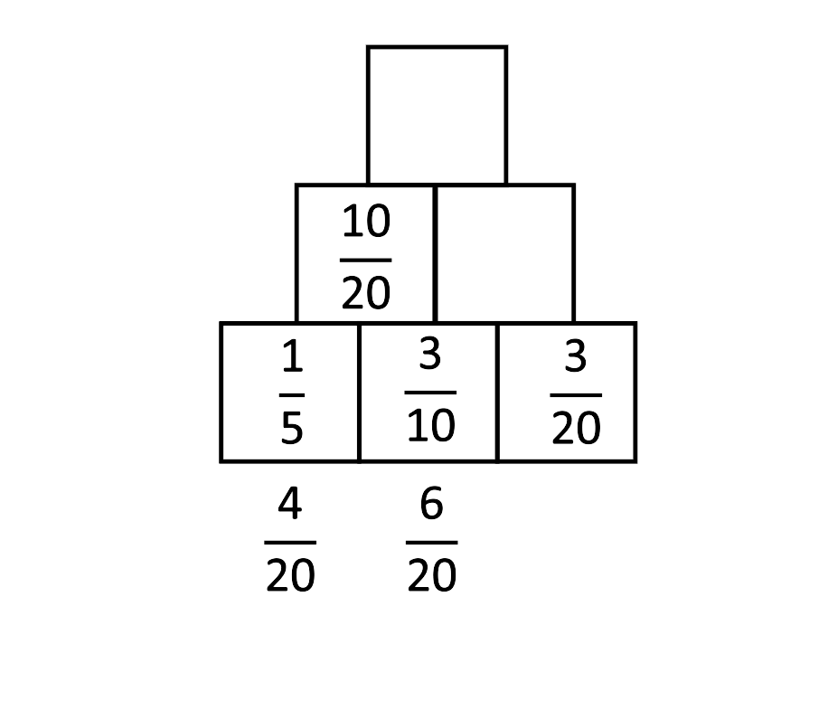

In some cases additional planning format will be required where support is needed or for ECTs and RQTs.

Unit Front Covers

For each unit, teachers prepare a front cover which outlines the intent, the learning objectives, key vocabulary and the outcome. This is stuck into the children’s books at the beginning of each unit for both adults and children to refer to. The vocabulary section is used within lessons to help enhance and support children’s reasoning language and understanding of the words within context.

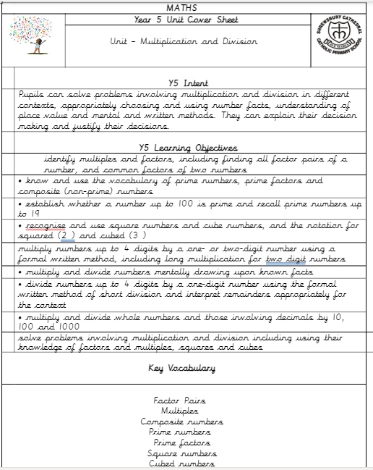

Impact
At SCCPS our pupils will;
- Become fluent, competent and efficient mathematicians.
- The ability to recall facts and procedures, including the recollection of times tables.
- The ability to recognise relationships and make connections in maths.
- The ability to clearly explain their reasoning and justify their thought processes.
- The flexibility to move between different contexts and representations of maths.
- High aspirations, which will see hem through to further study, work and a successful adult life.

EYFS

Children will;
- Secure firm foundations in the development of good number sense from Reception through to Year 1 and Year 2.
- Children will leave EYFS and be Year 1 ready with fluency in calculation and a confidence and flexibility with number.
- A good understanding of skills in counting, understanding and using numbers, calculating simple addition and subtraction problems; and to describe shape, spaces and measures.

Key Stage 1

The principal focus of mathematics teaching in Key Stage 1 is to ensure that pupils develop confidence and mental fluency with whole numbers, counting and place value. This should involve working with numerals, words and the four operations, including with practical resources (e.g. concrete objects and measuring tools). At this stage, pupils should develop their ability to recognise, describe, draw, compare and sort different shapes and use the related vocabulary.

Teaching should also involve using a range of measures to describe and compare different quantities such as length, mass, capacity/volume, time and money. By the end of Year 2, pupils should know the number bonds to 20 and be precise in using and understanding place value. An emphasis on practice at this early stage will aid fluency. Pupils should read and spell mathematical vocabulary, at a level consistent with their increasing word reading and spelling knowledge at Key Stage 1.

Lower Key Stage 2

The principal focus of mathematics teaching in lower Key Stage 2 is to ensure that pupils become increasingly fluent with whole numbers and the four operations, including number facts and the concept of place value. This should ensure that pupils develop efficient written and mental methods and perform calculations accurately with increasingly large whole numbers. At this stage, pupils should develop their ability to solve a range of problems, including with simple fractions and decimal place value. Teaching should also ensure that pupils draw with increasing accuracy and develop mathematical reasoning so they can analyse shapes and their properties, and confidently describe the relationships between them. It should ensure that they can use measuring instruments with accuracy and make connections between measure and number.

Multiplication Tables

By the end of Year 4, pupils should have memorised their multiplication tables up to and including the 12 x 12 and show precision and fluency in their work. Pupils should read and spell mathematical vocabulary correctly and confidently, using their growing word reading knowledge and their knowledge of spelling. All year 4 pupils will take the statutory multiplication test in the summer term.

Upper Key Stage 2

The principal focus of mathematics teaching in upper Key Stage 2 is to ensure that pupils extend their understanding of the number system and place value to include larger integers. This should develop the connections that pupils make between multiplication and division with fractions, decimals, percentages and ratio. At this stage, pupils should develop their ability to solve a wider range of problems, including increasingly complex properties of numbers and arithmetic, and problems demanding efficient written and mental methods of calculation. With this foundation in arithmetic, pupils are introduced to the language of algebra as a means for solving a variety of problems. Teaching in geometry and measures should consolidate and extend knowledge developed in number. Teaching should also ensure that pupils classify shapes with increasingly complex geometric properties and that they learn the vocabulary they need to describe them. By the end of Year 6, pupils should be fluent in written methods for all four operations, including long multiplication and division, and in working with fractions, decimals and percentages. Pupils should read, spell and pronounce mathematical vocabulary correctly.

In all Key Stages from EYFS to KS2 children are expected to be able to reason about maths and solve problems. This is done with concrete, pictorial and abstract resources so that all children can access this level of mathematics.

Planning and teaching are monitored by subject leaders and the head teacher throughout the school by classroom observation, book scrutiny and pupil and teacher interviews.

Mastery

Shrewsbury Cathedral School and Nursery have undertaken the ‘Teaching for Mastery’ (TfM) two-year course with the local authority Mathematics Hub lead by Catherine Hardy, (from 2018 – 2020). We have adopted an ongoing development within our action plan until 2021 to develop three key areas:

Area 1 | Area 2 | Area 3
STEM SENTENCES  - To promote mathematical language  - To support children with their reading within maths  - Trend of children arriving at school with us with low communication and language skills (EYFS) this will hopefully help to support them within mathematics and allow them to access the language to communicate their learning.  - This will also apply to our EAL learners | MODELS AND REPRESENTATIONS  - TfM models incorporated into the calculation policy  - Area, linear and quantity models.  - Use of Mastery PD materials.  - Helps to support deeper level questioning | SMALL STEPS  - To be used to help break down learning within class, specific to each class  - Assess the needs of your class (AFL) and use the NCTEM PD materials to support and enhance your planning where appropriate  - Not all areas will need to be broken down into steps this small

Assessment and Recording

Shrewsbury Cathedral Catholic Primary School have developed a system that is effective tracking attainment and progress over time and that they are on track to meet expectations at the end of the Key Stage. We assess children’s work in mathematics from three aspects (short-term, medium term and long-term).

Shrewsbury Cathedral Catholic Primary School and Nursery make short-term assessments which we use to help us adjust our daily plans. These short-term assessments are closely matched to the teaching objectives.
Assessment is done through
‘Helicopter marking which includes instant feedback, close the gap marking and teacher questioning. 1:1 intervention in the afternoon or next lesson to address misconceptions. Children will refer to this as think punk and purple polish.
Daily assessment is also carried out at the end of each lesson using the Learning Objective statements
I know that/which
I know how
I know when

Unit assessments are carried out before and at the end of a unit so that teachers can plan their lessons, assess progress, identify gaps and so that children can build confidence in their maths journey.
Revision and recap weeks are planned into the Long term plan to allow time to revisit areas.

We make long-term assessments three times a year, and we use these to assess progress against school and national targets. We can then set targets for the next school year/term and make a summary of each child’s progress before discussing it with parents. We use this information to create specific focus groups to ensure the children make expected and accelerated progress.

We pass this information on to the next teacher at the end of the year, so that they can plan for the new school year. We make the long-term assessments with the help of end-of-year tests, termly assessments and teacher assessments. Teachers meet regularly to review individual examples of work against the national exemplification material.

The maths coordinator will sample work to ensure consistency of assessment across the school and with other schools and the primary adviser. Teachers identify children who are not making the progress expected and interventions for both EYFS, KS1 and KS2 children are put in place to ensure progress of all pupils and to close the gap for groups of pupils.

Parents and Homework

We recognise the importance of the input parents have to their children’s education. All children are expected to carry out some homework for maths, in accordance with our homework policy. For years 1 – 5 these are focused mainly on the times tables facts and Key Instant Recall Facts. In Year 6 focus is on SATs style questions to provide a continual and consistent exposure to these worded questions to help deepen the children’s learning and to support mastery of the subject.

Equal Opportunities

As a staff we endeavour to maintain an awareness of, and to provide for equal opportunities for all our pupils in mathematics. We aim to take into account cultural background, gender and Special Needs, both in our teaching attitudes and in the published materials we use with our pupils.

This policy will be reviewed every three years or in the light of changes to legal requirements.

Headteacher:

Date:

Chair of Governing Body:

Date:

